Exploring Flavours in the Vortex Bar Series E-Liquids

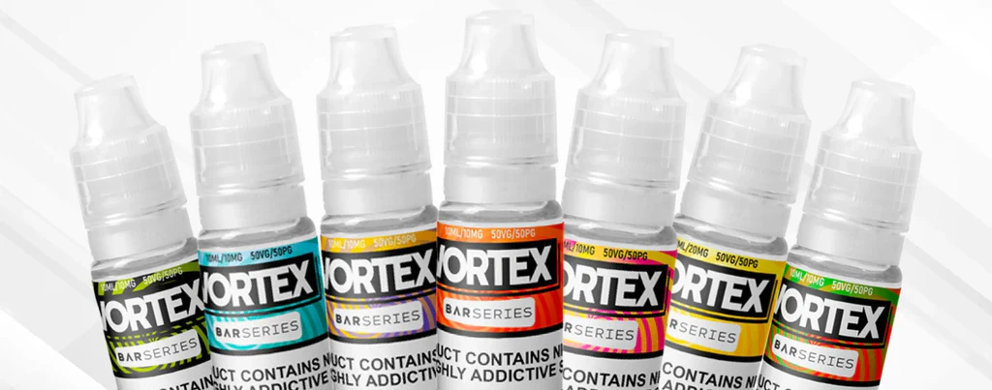

Introduction
The Vortex Bar Series E-Liquids have been designed for vapers who want dependable flavour delivery with smooth nicotine satisfaction. Unlike disposable kits that come prefilled and are discarded after use, these e-liquids allow users to enjoy the same taste profiles in refillable devices. This provides better value, more flexibility, and a lower environmental impact.
In this technical guide we will examine the composition, nicotine strengths, performance, and safety of the Vortex Bar Series E-Liquids. We will also look at the complete flavour range in detail and discuss how each performs in typical low-power devices.

Composition and Formulation
The Vortex Bar Series E-Liquids are based on nicotine salts. This type of nicotine is absorbed more quickly than freebase nicotine, providing faster relief from cravings. The throat hit is smoother, even at higher strengths, which makes the liquids suitable for both beginners and experienced users.
The blend uses a higher ratio of propylene glycol (PG) than vegetable glycerine (VG). This ensures strong flavour delivery and efficient wicking in pod systems and starter kits. The vapour production is moderate, which suits mouth-to-lung style devices.
Nicotine strengths available:
- 5 mg/ml
- 10 mg/ml
- 20 mg/ml
Each bottle contains 10 ml of liquid, in line with UK TPD regulations.

Device Compatibility
The Vortex Bar Series E-Liquids are designed for use in pod systems, starter kits, and other low-power mouth-to-lung devices. The thinner consistency created by the higher PG ratio makes them unsuitable for sub-ohm tanks, which are intended for thicker high-VG liquids.
In pod kits the performance is consistent, with clear flavour and smooth vapour. Coils wick easily and maintain stability across the lifespan of the bottle.

Flavour Range
The Vortex Bar Series covers fruit, menthol, beverage, and tobacco categories. Each flavour is designed to replicate popular disposable options while providing the benefits of a refillable format.

Sour Blueberry Raspberry
A blend of sweet blueberry and sharp raspberry, finished with a sour twist. The combination balances sweetness and tartness for a more dynamic flavour.

Mad Blue
A mixed berry profile that layers blueberries, raspberries, and darker fruits. It delivers both sweet and tangy notes, making it suitable for users who want complexity in their liquids.

Pineapple Ice
Crisp pineapple flavour with a cool menthol undertone. The tangy edge keeps it refreshing without overwhelming sweetness.

Cream Tobacco
A tobacco base with a smooth creamy finish. This is one of the few tobacco-style options in the series, designed for users who prefer a more traditional profile.

Strawberry Lime
Sweet strawberry combined with zesty lime. The sharp citrus note balances the fruit base, keeping the overall taste bright.

Beetle Juice
A playful fruit blend with layered sweetness. It delivers a distinctive flavour that stands out from single-fruit profiles.

Strawberry Ice
Classic strawberry with a cool menthol finish. Smooth and light, it suits users who want a familiar flavour with an added refreshing touch.

Watermelon Ice
Fresh watermelon with a chilled edge. The flavour is light and clean, suited to all-day use.

Cherry Raspberry
A two-fruit mix of bold cherry and tart raspberry. The pairing creates a balanced profile that is neither too sweet nor too sharp.

Lemon and Lime
Sharp citrus blend of lemon and lime, with a fizzy character that resembles a soft drink. Crisp and zesty.

Sour Cherry
Bold cherry flavour with a sour twist. This option has more sharpness than the standard cherry profiles, making it more distinctive.

Mojito
A beverage-inspired option that blends lime, mint, and a hint of sweetness. It replicates the taste of the classic cocktail without being overpowering.

Peach Apricot
Smooth peach combined with sweet apricot. The blend is mellow and fruit-forward, offering a softer option compared with sharper citrus flavours.

Pink Lemonade
Refreshing lemonade with a berry twist. The result is tangy yet smooth, designed to appeal to users who enjoy beverage-style liquids.

Raspberry Mojito
A variation on the Mojito, with added raspberry sweetness and tartness layered over the lime and mint base.

Cola Slushie
Sweet cola flavour with a cooling finish. It mimics the sensation of a frozen cola drink and offers a change from fruit profiles.

Sour Apple
Crisp green apple with a tart edge. The sour note keeps it sharp and refreshing.

Apple Peach
Juicy apple mixed with sweet peach. The balance of crisp and smooth fruit notes makes it an easy all-day choice.

Raspberry Lemon
Tart raspberry paired with sharp lemon. The citrus element intensifies the overall flavour, giving it a more prominent edge.

Performance and Vapour Production
When tested in pod systems, the Vortex Bar Series liquids deliver steady flavour and moderate vapour output. The higher PG ratio ensures that coils wick without issue, even in compact devices with small wicking ports.
Flavour clarity: Each option maintains its profile from the start of the bottle to the end.
Throat hit: Smooth, with no harshness at standard strengths.
Vapour production: Modest, which suits discreet use.
The nicotine salt formulation ensures satisfaction without excessive irritation.

Safety and Compliance
The Vortex Bar Series E-Liquids comply with UK TPD regulations:
- 10 ml maximum bottle size
- Maximum strength of 20 mg/ml
- Tamper-evident seals and childproof caps
- Full ingredient labelling
The liquids contain propylene glycol, vegetable glycerine, flavourings, and nicotine salt. They do not contain diacetyl or other banned additives.

Storage and Shelf Life
E-liquids should be stored in a cool, dark place away from sunlight and heat. Prolonged exposure to heat or light can degrade both nicotine and flavourings.
The Vortex Bar Series bottles carry a typical shelf life of up to two years from the date of manufacture. Users should always check the expiry date printed on the packaging before use.

Cost and Value
The series is priced competitively, with bottles often available through bundle deals such as three for £10 or ten for £20. Compared with disposables, each 10 ml bottle provides the equivalent of several prefilled devices, at a much lower overall cost.
This makes the Vortex Bar Series a strong choice for regular users who want the same flavour experience as disposables without the higher price point.

Environmental Considerations
Each Vortex Bar bottle is recyclable, reducing waste compared with disposable devices that include both plastic casings and batteries. For environmentally conscious users, moving from disposables to refillable kits with these liquids is a practical way to reduce impact.

Who the Series Is For
The Vortex Bar Series E-Liquids are suitable for:
- New vapers moving away from disposables
- Users of pod kits and starter devices
- People seeking a variety of fruit, ice, and beverage flavours
- Smokers transitioning to vaping who want smooth nicotine salt delivery
They are less suitable for hobbyist vapers seeking high-power devices and large vapour clouds.

Strengths
- Wide flavour range covering fruit, menthol, beverage, and tobacco
- Smooth nicotine salt formulation
- Available in three nicotine strengths
- TPD compliant with clear labelling
- Competitive pricing and bundle offers
- Lower environmental impact than disposables

Comparison with Other Nicotine Salt Liquids
When compared with other nicotine salt liquids on the UK market, the Vortex Bar Series stands out for its flavour range that mirrors disposable favourites. While some brands focus heavily on tobacco or dessert profiles, Vortex keeps its range centred on fruits and ice blends, which remain the most popular among disposable users.
The pricing is competitive, particularly with multi-buy deals. Flavour consistency is also reliable, with little variation between batches.

What makes them stand out?
The Vortex Bar Series E-Liquids bring together variety, consistency, and practicality. With flavours ranging from fruity blends like Sour Blueberry Raspberry to beverage options like Cola Slushie and Mojito, the series caters to a wide audience. The nicotine salt formulation provides smooth delivery, while the higher PG blend ensures reliable performance in pod systems.
By choosing these liquids, vapers gain both value and choice. They offer the same profiles enjoyed in disposable kits but in a refillable form that is more cost-effective and less wasteful. For anyone looking to make the transition from disposables or seeking dependable e-liquids for everyday use, the Vortex Bar Series stands as a strong option.

Why Buy the Vortex Bar Series from Tidal Vape
At Tidal Vape we stock the full range of Vortex Bar Series E-Liquids, with all flavours and nicotine strengths available. Orders placed before 1 pm on weekdays are dispatched the same day, and we offer multi-buy deals such as three bottles for £10 or ten for £20, giving you better value if you are buying regularly.
You can order directly through our website or visit one of our stores across the UK. Every product we sell is TPD compliant and sourced from trusted manufacturers, so you can be confident that you are buying genuine and safe e-liquids.
For anyone moving from disposables to refillable kits, our team can also recommend compatible devices that work best with the Vortex Bar Series, ensuring you get the right setup from the start.

