Find the Right VooPoo Argus Kit at Tidal Vape
The VooPoo Argus Series is a collection that has steadily grown in popularity thanks to its wide range of devices. Each kit and pod has been designed with everyday use in mind, offering different features for beginners and advanced vapers alike. At Tidal Vape, the entire line is available with fair pricing and convenient delivery across the UK.
- Wide range of Argus devices on offer
- Affordable prices starting under £15
- Options for beginners and advanced users
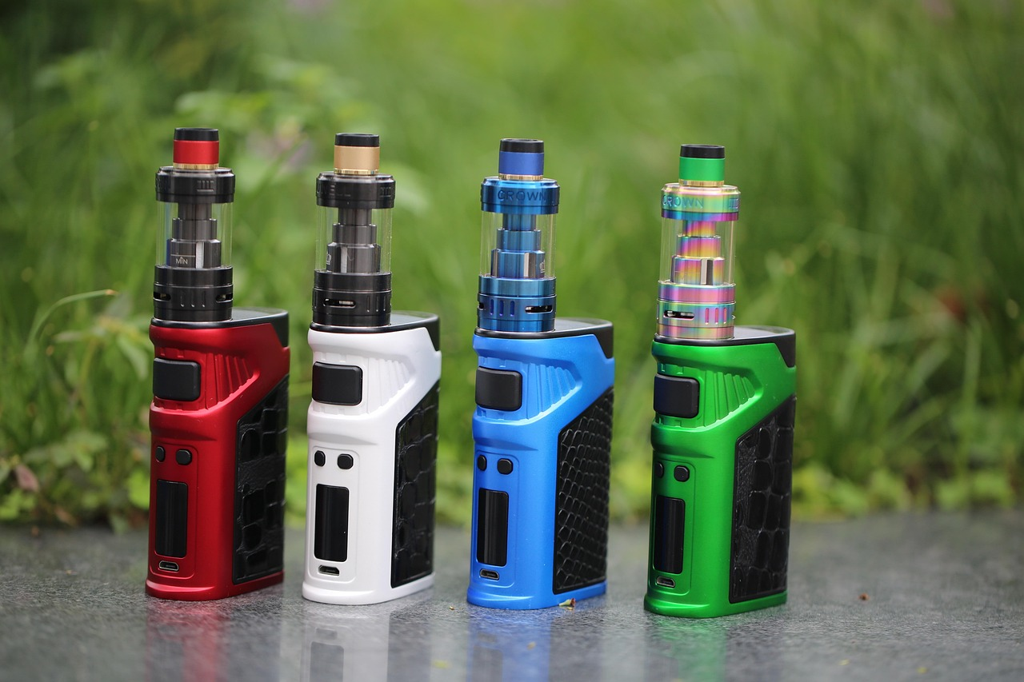
Why the Argus Series Matters
The Argus Series has become one of VooPoo’s most recognisable product families. It covers multiple formats, including simple pods and more advanced sub-ohm kits. This makes it an adaptable line that appeals to a broad group of vapers.
- Range spans beginner-friendly kits to advanced mods
- Pod options for convenience
- Larger kits for customisation and control
Range of Products at Tidal Vape
Tidal Vape currently stocks fourteen products in the VooPoo Argus Series. These include entry-level devices, premium pod systems, and supporting accessories such as replacement pods. The line-up changes from time to time, but the core devices remain easy to find on the store’s site.
- Fourteen Argus products listed
- Options for pod kits, starter kits, and pro kits
- Accessories like cartridges and replacement pods also available
VooPoo Argus G3 Mini
The Argus G3 Mini is one of the most compact devices in the series. It is priced at £12.99, making it one of the cheapest in the collection. Despite its small size, it delivers consistent vapour and is suitable for light or casual use.
- Compact and pocket-friendly design
- Priced at £12.99
- A good choice for beginners or light users
VooPoo Argus G3
The Argus G3 is a step up from the Mini. It is priced at £26.99 and offers more power with a slightly larger body. The device suits users who want a balance between portability and performance.
- Price point of £26.99
- Slightly larger than the Mini for improved battery capacity
- Balances power and portability
VooPoo Argus Z2 Pod Kit
The Argus Z2 Pod Kit is one of the simplest in the series. Priced at £9.99, it is budget-friendly and makes vaping straightforward for beginners. It uses a replaceable pod system, removing the need for complicated coil changes.
- Priced at £9.99
- Easy to use for first-time vapers
- Uses replacement pods instead of coils

VooPoo Argus A Pod Kit
The Argus A Pod Kit is one of the mid-tier products. At £29.99, it offers a well-rounded feature set, including strong battery life and sleek design. It suits vapers looking for a simple yet capable everyday device.
- Price point of £29.99
- Strong battery performance
- Designed for daily use
Argus E40 Pod Kit
The Argus E40 Pod Kit also costs £29.99. It focuses on providing a larger battery and better vapour output while keeping portability. Its design appeals to those who want a reliable pod system with solid build quality.
- Priced at £29.99
- Long battery life
- Strong vapour production
Argus P2 Vape Kit
The Argus P2 is part of the newer generation of Argus devices. It is currently marked as sold out on the Tidal Vape site, which reflects its demand. Users value its upgraded features and balanced performance.
- Currently sold out
- Updated design and features
- Popular choice among experienced users
VooPoo Argus Pro 2 Kit
The Argus Pro 2 Kit is priced at £35.99. It is designed for more advanced vapers who want to customise their vaping style. The device allows for greater power adjustment and control.
- Price of £35.99
- Customisable power settings
- Suited for advanced vapers
VooPoo Argus P1S Pod Kit
The Argus P1s is available at £24.99. It is a stylish pod kit with a transparent body and fast charging features. This makes it suitable for users who like modern designs along with dependable performance.
- Price of £24.99
- Transparent modern design
- Quick charging capability
Replacement Pods and Cartridges
Alongside full kits, Tidal Vape also stocks replacement pods for the Argus Series. These are typically sold in packs of three. Buying them ensures users can continue using their Argus device without interruptions.
- Packs of three replacement pods
- Easy swap system for convenience
- Keeps devices running smoothly
Price Range
The Argus Series at Tidal Vape covers a broad price range. The cheapest device is the Argus Z2 Pod Kit at £9.99, while the higher-end kits like the Argus Pro 2 are around £35.99. Accessories and pods are generally priced lower, making them affordable for routine purchases.
- Cheapest kit starts at £9.99
- Higher-end kits around £35 to £45
- Accessories priced affordably
Delivery and Convenience
Tidal Vape offers quick and reliable delivery services. Orders placed before 1 pm are dispatched the same day. Free next-day delivery is also available for orders over £24.
- Same-day dispatch for orders before 1 pm
- Free next-day delivery on orders over £24
- Reliable shipping across the UK
Beginner Friendly Choices
For beginners, the Argus Z2 and Argus G3 Mini stand out. These devices are simple to use and inexpensive, making them ideal first kits. They remove the complexity often linked with advanced vaping setups.
- Easy to use without steep learning curve
- Low entry cost for new vapers
- Compact and portable designs
Options for Experienced Users
Advanced users often prefer the Argus Pro 2 or the Argus P2. These kits provide adjustable settings and more power for customised use. They are also built with sturdier materials to handle longer sessions.
- Adjustable settings for experienced users
- Larger battery capacities
- Better suited for heavy use
Pod Systems
Most of the Argus Series consists of pod systems. Pods are simple, lightweight, and can be replaced easily. This makes them a practical choice for both beginners and those who value convenience.
- Simple replacement pods
- Lightweight builds
- Convenient for daily carry
Sub-Ohm Options
While pod systems dominate the range, there are also sub-ohm kits for cloud chasers. The Argus Pro 2, for instance, is capable of sub-ohm vaping. This gives users stronger flavour and larger vapour clouds.
- Sub-ohm capability in certain kits
- Stronger flavour and cloud production
- Appeals to hobbyist vapers
Build Quality
The Argus Series is known for its build quality. Devices use strong materials that feel solid while remaining portable. Each kit is designed to withstand regular daily use.
- Durable build materials
- Designed for everyday use
- Solid and reliable feel
Design and Style
VooPoo pays attention to design in the Argus line. Transparent bodies, sleek lines, and modern finishes make the kits visually appealing. Users can pick from various colours at Tidal Vape.
- Stylish and modern finishes
- Transparent designs available
- Multiple colour options
Charging and Battery Life
Battery life differs between models. Smaller kits like the G3 Mini are more compact but have smaller batteries, while the Pro 2 offers extended life. Many devices also feature fast charging through USB-C.
- Battery sizes vary by model
- Fast USB-C charging in newer kits
- Longer life in larger models
Flavour Experience
Pods in the Argus Series are designed to deliver clear flavour. The airflow systems and coil designs work to improve taste. Users report that flavour consistency is one of the strong points of the Argus line.
- Clear and consistent flavour
- Improved airflow in pod designs
- Pods retain flavour quality across use
Coil and Pod Longevity
One advantage of the Argus Series is the longevity of its pods and coils. Replacement pods are built to last for multiple refills. This reduces the overall cost of using the devices.
- Long-lasting pods and coils
- Supports multiple refills
- Lower running costs over time
Maintenance and Upkeep
Maintenance is straightforward for Argus devices. Most kits rely on pod changes, so there is no need for advanced coil fitting. Regular cleaning keeps the device in good condition.
- Simple pod replacement system
- No need for coil building
- Easy to clean and maintain

Popularity and Demand
The Argus Series continues to be in demand, as shown by products like the Argus P2 selling out. Its mix of affordability and quality keeps it attractive to users. Tidal Vape frequently restocks popular items.
- High demand shown by sold-out products
- Balanced mix of price and performance
- Regular restocks on the website
Safety Features
Many Argus devices include built-in safety measures. These protect against overcharging, overheating, and short circuits. Such features make them safe for daily use.
- Built-in safety protections
- Guards against overcharging and overheating
- Suitable for everyday carry
Comparison with Other Brands
Compared with similar ranges from other brands, the Argus Series holds its own. It combines affordability with features usually found in higher-priced kits. This balance makes it a competitive choice in the UK market.
- Affordable compared with rivals
- Strong feature set for the price
- Reliable performance across the series
Customer Benefits at Tidal Vape
Buying from Tidal Vape comes with additional benefits. Customers can rely on quick delivery, a wide range of stock, and customer service support. This ensures a smoother buying experience.
- Wide selection of Argus products
- Reliable delivery policies
- Customer service available for queries
Legal and Age Restrictions
Vaping products are restricted to users over the age of eighteen in the UK. Tidal Vape includes age verification steps to comply with this law. Customers must ensure they meet these requirements when ordering.
- Age limit of eighteen years
- Age verification at checkout
- Compliance with UK laws
Final Thoughts
The VooPoo Argus Series provides an accessible and well-rounded range of vaping devices. From budget pods to advanced kits, there is something for every user. Tidal Vape makes these devices easy to buy, with quick delivery and affordable prices.
- Broad selection for beginners and advanced users
- Affordable pricing across the range
- Reliable buying experience at Tidal Vape

