Best Vape Kits for Every Budget
If you have spent even a little time looking at vape kits, you will know how quickly things can get confusing. New models drop every month, brands keep updating their ranges, and suddenly you are staring at a dozen options that all claim to be better than the last.
So instead of making things complicated, we are keeping it simple.
This guide walks you through the best selling vape kits available right now at Tidal Vape. These are the kits people keep coming back for. The ones that get recommended, re-bought, and talked about.
Whether you are switching from disposables, upgrading your current device, or just want something reliable, this list will help you find your next vape.
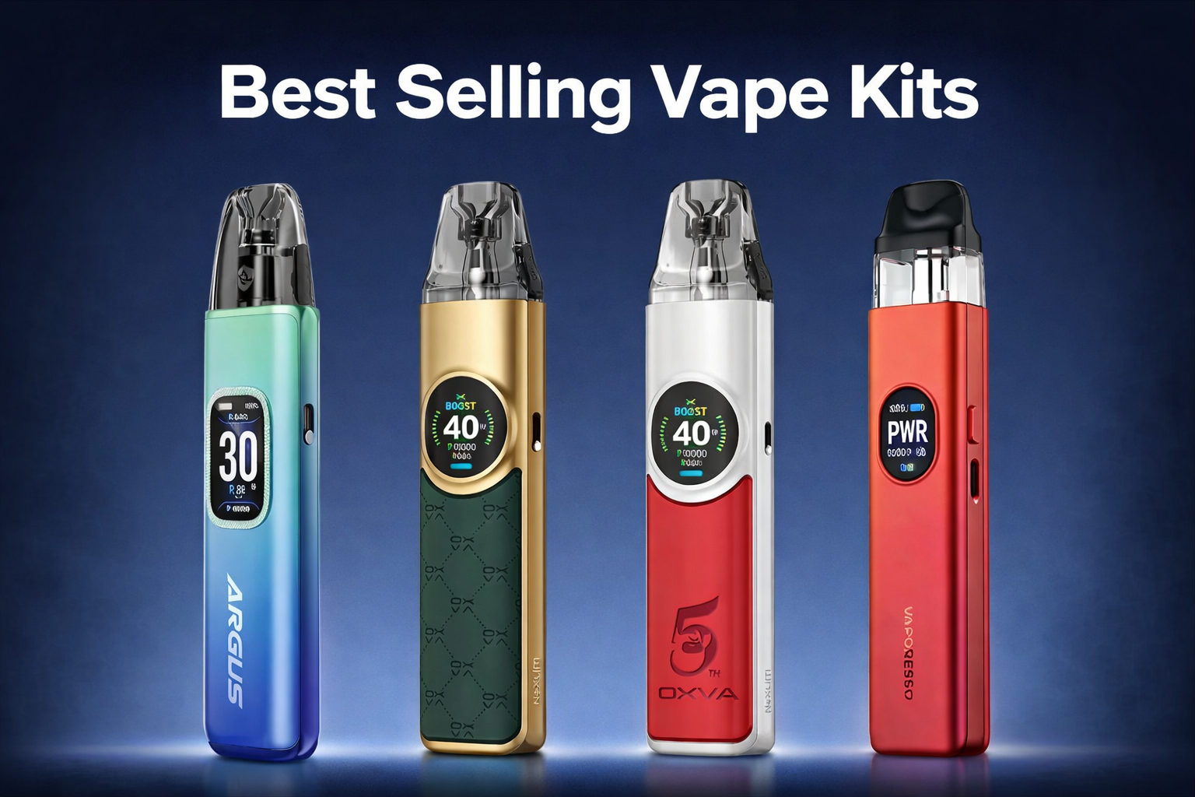

Why these vape kits are selling so well
Before jumping into the kits themselves, it helps to understand what makes a vape kit popular in the first place.
It is rarely about hype. It is about consistency.
The best selling kits tend to offer:
- Simple setup with no learning curve
- Reliable battery life that lasts all day
- Strong flavour without constant tweaking
- Durable build that survives daily use
- Pods or coils that are easy to replace
Most importantly, they work straight out of the box without needing adjustments every few hours.
That is what keeps people coming back.

Pod kits that everyone keeps buying
Pod kits dominate the market right now. They are compact, easy to carry, and perfect for everyday use.

OXVA Xlim Pro 3 Pod Kit
The Xlim series has built a solid reputation, and this version continues that trend.
- Smooth airflow control
- Strong battery for its size
- Crisp flavour with every puff
It is ideal if you want something small but dependable.

Voopoo Argus G3 Vape Kit
Voopoo knows how to make a reliable pod kit, and the Argus G3 proves it.
- Comfortable grip
- Long battery life
- Clean, consistent output
A great option if you want something that feels sturdy without being bulky.

Classic One Pod Vape Kit
Sometimes simple is better.
- No complicated settings
- Easy refill system
- Straightforward performance
Perfect for beginners or anyone who wants a no-fuss vape.

Vaporesso Xros 5 Pod Vape Kit
The Xros line has always been known for flavour, and this one keeps that standard high.
- Excellent coil performance
- Smooth draw
- Compact design
A favourite for everyday use.

OXVA Nexlim Vape Kit
A newer addition that has quickly gained attention.
- Modern design
- Balanced power output
- Reliable pods
It sits nicely between beginner-friendly and slightly advanced.

Xlim SQ Pro 2
A different take on the usual pod design.
- Square shape for better grip
- Strong battery
- Clean flavour delivery
A great pick if you want something that feels a bit different.

OXVA Xlim 3 Ultra Pod Kit
This one pushes the Xlim range further.
- Improved airflow
- Better battery performance
- Consistent vapour production
Ideal for those upgrading from older Xlim models.

Xlim Pro 2 by OXVA
Another solid performer in the lineup.
- Sleek design
- Easy to use
- Strong flavour output
A safe choice if you want reliability.

Pava Horiz Ultra Pod Vape Kit
A rising name that is getting noticed.
- Lightweight build
- Smooth airflow
- Good battery life
Great for everyday carry.

Vaporesso Luxe XR Max 2 Pod Vape Kit
A more powerful pod kit for those who want extra performance.
- Larger battery
- Adjustable output
- Strong vapour production
It bridges the gap between pod kits and bigger devices.

Vaporesso Xros 4 Nano Pod Kit
Compact, stylish, and easy to use.
- Pocket-friendly size
- Reliable coils
- Great for nicotine salts
Perfect for quick, hassle-free vaping.

Voopoo Argus A Pod Vape Kit
Another strong entry from Voopoo.
- Durable build
- Consistent performance
- Easy maintenance
Works well for both new and experienced users.

OXVA Nexlim Go
A simplified version of the Nexlim.
- Lightweight
- Easy to use
- Good value
Ideal for beginners or as a backup device.

Box mod kits for more power
While pod kits dominate, box mods still have their place.
They are built for those who want more control, more power, and bigger clouds.

Voopoo Vinci Spark220 Box Mod Kit
If you want performance, this delivers.
- High power output
- Advanced settings
- Strong build quality
It is designed for experienced users who want full control.

Vaporesso Armour Ultra 100W Box Kit
A tough and reliable option.
- Durable design
- Strong battery performance
- Consistent output
Built for those who want something that lasts.

Choosing the right vape kit for you
With so many options, the real question is not which kit is best. It is which one fits your lifestyle.
Here is a quick way to narrow it down.
If you are new to vaping
Start simple.
- Classic One Pod Kit
- OXVA Nexlim Go
- Vaporesso Xros 4 Nano
These are easy to use and require little setup.
If you want something compact
Go for portability.
- Xlim Pro 3
- Argus A
- Xlim SQ Pro 2
They are small enough to carry anywhere.
If flavour matters most
Focus on coil quality.
- Vaporesso Xros 5
- OXVA Xlim 3 Ultra
- Luxe XR Max 2
These deliver clean and consistent flavour.
If you want more power
Step up to advanced kits.
- Vinci Spark220
- Armour Ultra 100W
These give you control over every detail.

What makes a vape kit worth it
It is easy to get distracted by specs, but real value comes from daily use.
A good vape kit should:
- Feel comfortable in your hand
- Last through your day without constant charging
- Deliver consistent flavour
- Be easy to maintain
If it ticks those boxes, it is doing its job.

Why buy from Tidal Vape
There are plenty of places to buy vape kits, but not all of them offer the same experience.
At Tidal Vape, the focus is on:
- Stocking trusted brands
- Offering genuine products
- Keeping prices fair
- Providing reliable customer support
It is not just about selling devices. It is about making sure you get something that actually works for you.

Closing thoughts...
The best selling vape kits are not just popular by chance. They earn that position by delivering what people need every day.
Some are simple and compact. Others are powerful and customisable. But they all share one thing in common.
They work.
If you are still unsure, start with something simple and build from there. You do not need the most advanced device to have a good experience.
And if you are ready to upgrade, there is no shortage of solid options waiting for you.
Take your pick, keep it simple, and enjoy the process.

